Dear Mr. Watchorn,

I am writing to provide you with an update on my progress for Assignment 5 in ECE 101, which involved working with MATLAB to plot and analyze data.

Executive Summary:

In this assignment, I created two datasets and plotted them. The first dataset involved simple and damped harmonic motion, and the second dataset was a sound recording of a lecture. I plotted the raw data and smoothed data for both datasets and calculated the maximum values. I also saved the datasets as readable files.

Discussion:

To create the datasets, I decided to use dummy time vectors and define parameters for simple and damped harmonic motion. For the second dataset, I recorded a sound clip of a lecture. I chose these datasets because they are relevant to electrical engineering and allow me to apply the concepts we have learned in class.

I also made decisions about documentation, modularity, and style. For documentation, I used comments throughout the code to explain each step and the purpose of the code. For modularity, I separated each dataset and plot into its own section. For style, I used consistent variable naming and spacing throughout the code.

Outcomes:

For the first dataset, I plotted the data and the smoothed data for both simple and damped harmonic motion. I also labeled the maximum points and calculated the frequency. The maximum displacement for the smoothed simple harmonic motion was 0.64, and the maximum for the smoothed damped harmonic motion was 0.54. The frequency for the smoothed simple harmonic motion was 1.10 Hz, and the frequency for the smoothed damped harmonic motion was 1.10 Hz. See Figure 1 at the end of this email for the plot.

For the second dataset, I plotted the raw data and the smoothed data for a sound clip of a lecture. I also labeled the maximum point. The maximum volume was 0.2. See Figure 2 at the end of this email for the plot.

This took about 19 hours to create, including sleeping overnight and pauses in work. Without sleeping and pauses, this took about 8 hours to create.

Conclusions:

Overall, this assignment was a valuable opportunity to apply the concepts we have learned in class to real-world data. I was able to create datasets, plot the data, and analyze the results. Through this process, I gained a better understanding of how MATLAB can be used in the field of electrical engineering.

Thank you for your time and feedback.

Best regards,

Michael Dekoski

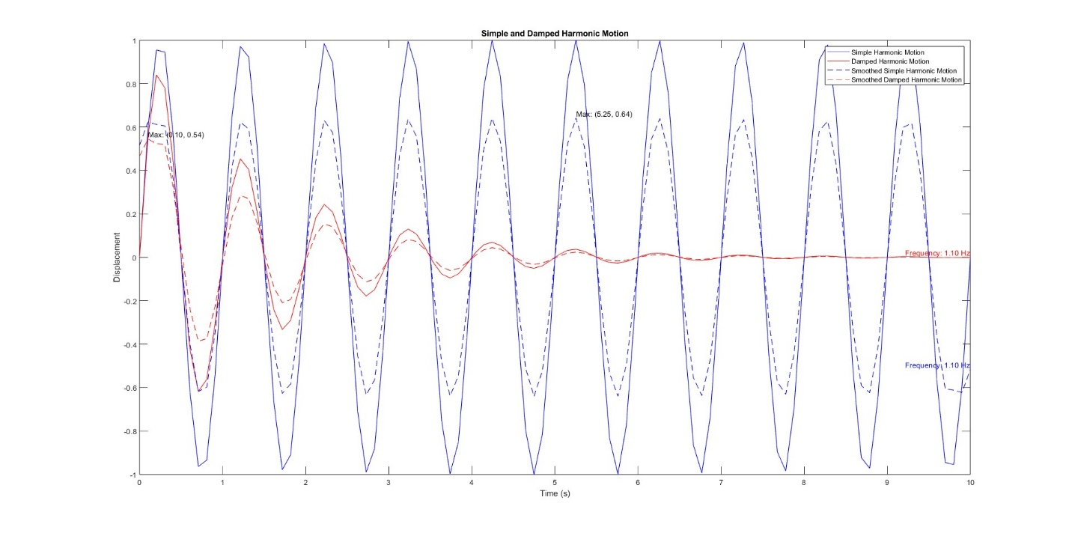

Figure 1: Simple and Damped Harmonic Motion Plot

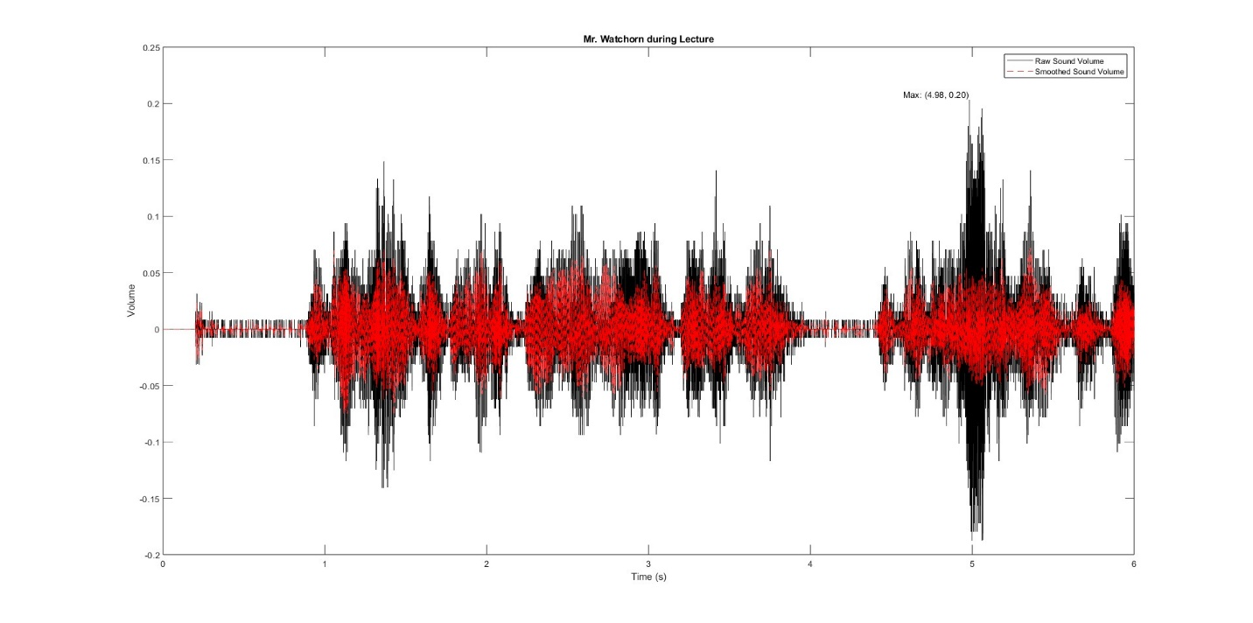

Figure 2: Mr. Watchorn during Lecture